Fan Apartments, Inc.
P.O. Box 5541
Richmond, VA 23220

Phone: (804) 358-4784 Fax: (804) 359-3385
Maintenance: fanmaintenance@aol.com

How to Change a Blown Fuse

Occasionally, a neighborhood—or even an entire city or region—will experience a large-scale power outage. There's little you can do about this from your home, of course, so it's important to keep fresh batteries, a flashlight or two and a battery-operated radio on hand at all times.
More typically, power failures are confined to the home. When a fuse turns off or "blows" what do you do? This flyer will walk you through the steps of how to change a fuse. NOTE: If it blows again, you need to find out the root cause of the problem because something is overloading your circuit or creating a short circuit. Contact our Maintenance Department in writing by email, fax or mail.
1. The first step is to go the electrical fuse box for your apartment marked by apt# on the box.
Fuses: a fuse is like a screw, or light bulb, that completes a specific electrical circuit. When the circuit is overloaded, the fuse may “blow”. When this happens, the connection within the fuse breaks, the circuit is no longer complete and the power goes out.

2. The next step is to identify the blown fuse.
- Look closely at each fuse. The window on a good fuse will be clear. The window on a fuse that has “blown” to cut off the power and protect the circuit will be cloudy black or gray. That is the fuse that needs to be replaced.

3. Replacing the fuse is easy.
- To replace the “blown” fuse, you will need to turn the fuse counter clockwise to remove it. Replacement fuses are available at any grocery or hardware store. Take the dead, blown fuse with you to the store when purchasing a replacement. The exact same fuse type must be used for power to be restored (i.e. same color, shape, etc.). Install the new fuse by inserting it into the fuse socket and turning it clockwise until it is tight. The power to that circuit should now be restored.
- If the fuse blows again, you need to determine the reason for the over current condition and correct the root cause of the problem. The fuse may be blowing due to excessive amperage in the circuit or may be shorting out. Contact our Maintenance department by email, fax or mail.

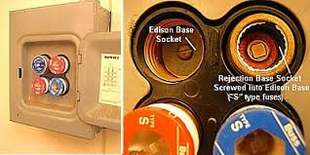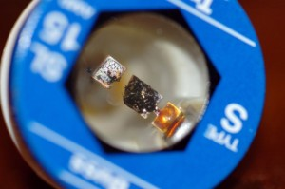
What a typical blown fuse looks like

