Fan Apartments, Inc.

P.O. Box 5541

Richmond, VA 23220

# Phone: (804) 358-4784 Fax: (804) 359-3385

Maintenance: fanmaintenance@aol.com

# **How to Relight a Stove & Oven Pilot Light**

# **If you can light a candle, you can do it!**

# Your stove has 3 tiny blue flames which stay on all the time so you can use your stove and oven just by turning up the gas.Lighting the pilot lights on your stove is simple and safe.  Follow the instructions and you’ll be cooking in no time.

1.  Make sure that the stove knobs are all set to the "off" position

2.  Pull the top of the stove up firmly. You can grip it by the edge or pull it up using the front burner openings.

3.  Notice the small metal pipes between each set of burners: one for the left, one for the right sides. The gas jet is located in the middle, where the pipes open.

4.  Place your lit match or lighter by the gas jet. It should light immediately with a small blue flame.

5.  Use your stove as usual

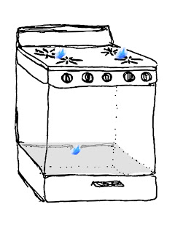

**This illustration shows the location of the pilots,  
though the flames are actually much smaller.**

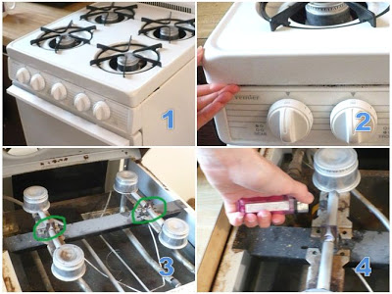

6. If the pilot lights for the stove are both on and you can still smell gas, please check to see if the third one for the oven is lit. You can see it if you open the broiler door and look all the way in the back. The best way to light it is with a lighter and—here’s the fun part— lie on your back and reach all the way to the rear of the broiler drawer. There is a small bundle of narrow tubes that are the same as the ones in the stove. Push in the oven control knob and hold while you place the lighter flame near those tubes and it will relight the oven pilot. Release the oven knob and use the oven as usual

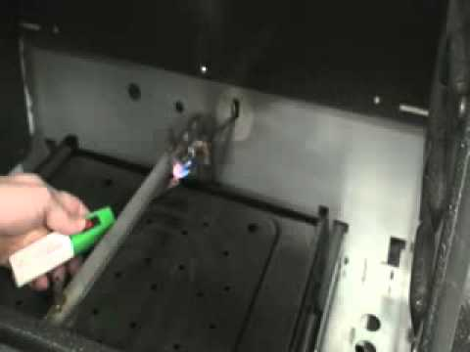

## Tips & Warnings

* The amount of gas that comes through for a pilot light is very small. If your pilot lights are lit and you still smell gas

please call your gas company - **Dial 311**.

* If the pilot lights go out repeatedly, email a maintenance professional to look at the stove: **fanmaintenance@aol.com**